Form Client Returned/Changed/Refund Item

Outlet: Receipt Number:
Date/Time:
Key Responsibilities:

- All supervisor are obligated to record the client’s Phone and Sign on the issued receipt and fill in the form then after attaching the Both Receipts

- According to the company policy, all authorities who are in charge must sign this form, separately.

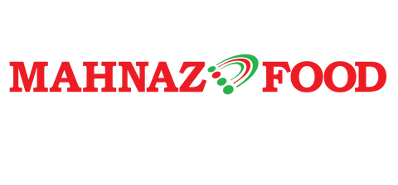

RETURNED ITEM
SKU | Description Item | Qty | Unit  Price | Reason
Comments:

EXCHANGED ITEM
SKU | Description Item | Qty | Unit  Price | Reason
Comments:

Signature By:
1) Supervisor:
2) Customer & Contact Number:
Date & Time
Date & Time
(
)
(
)

